Design Sketch

Date: 24/03/2020

Team Name: -

Team Members: Antonio Butigan and Josip Muzic

Rough Class Diagram:

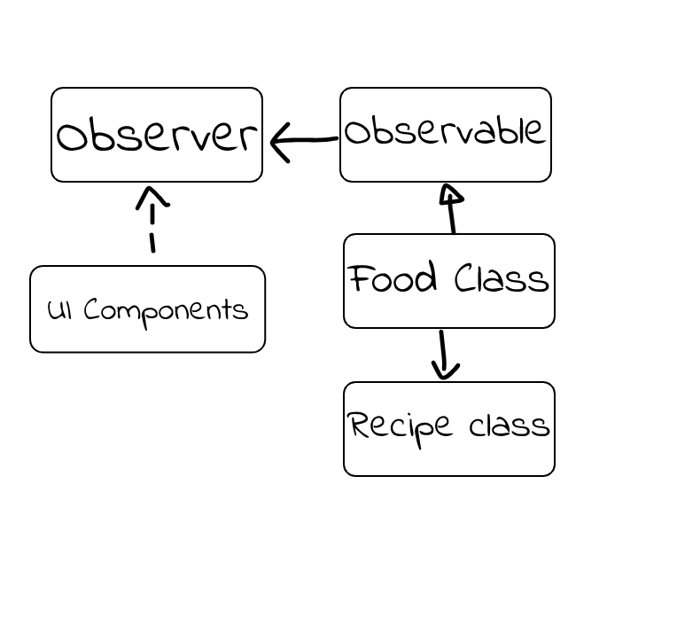

Rough Sequence Diagram:

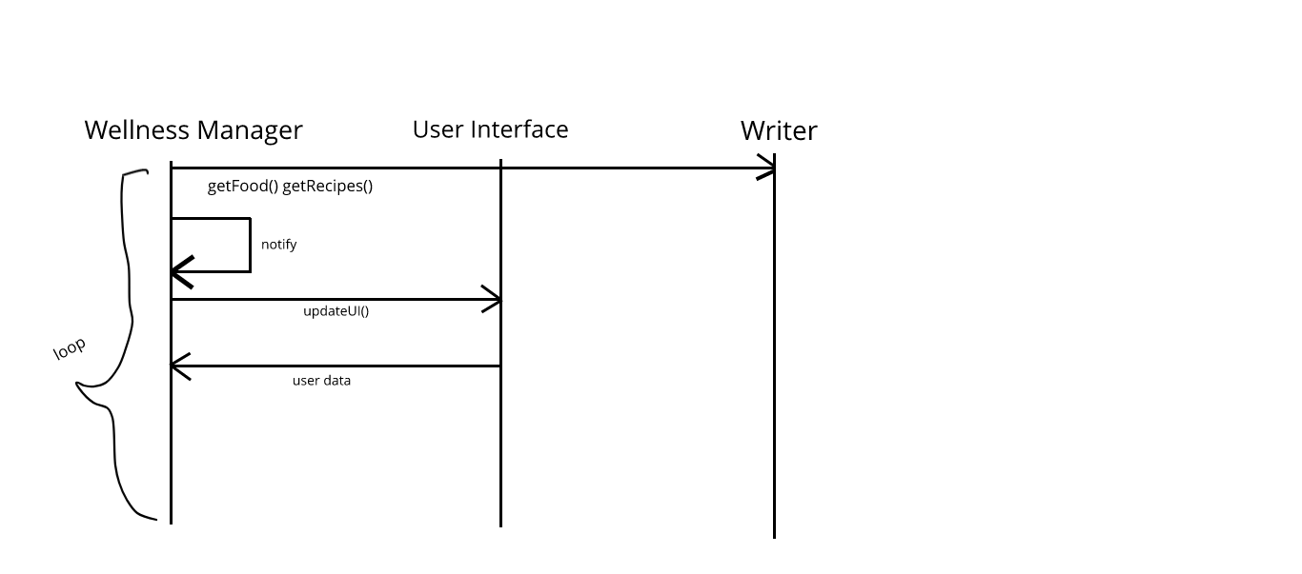

Class Diagram

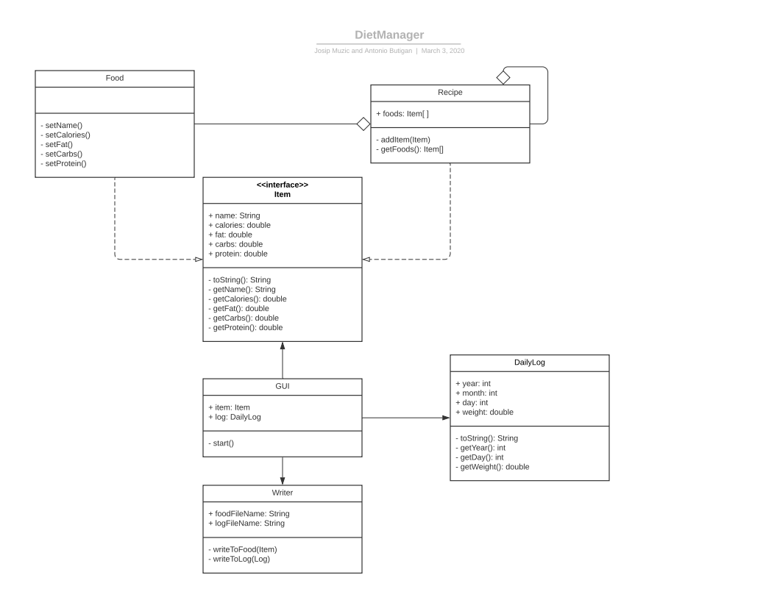

Food class will contain 5 methods, it is simply a data class, so is the Recipe class but it will contain food objects. Both of them implement the Item interface. The GUI will use these Data classes to easier implement them and show the right data.

The DailyLog will just be used to show graphs and functions like that. The writer will handle both the input and output of the app.